Data Cleaning and Preparation for Agribusiness Analysis
Week 2 Task | Junior Data Analyst - Agribusiness Internship | Yuva Intern

1. Introduction
This report documents the data cleaning and preparation process applied to a real, publicly available agribusiness dataset: the Crop-Wise Area, Production and Yield (APY) dataset from India Data Portal, sourced from the Directorate of Economics and Statistics, Ministry of Agriculture and Farmers Welfare, Government of India. The dataset covers 455,359 records spanning 1997-2023, across 34 states/UTs and 740 districts, recording area cultivated, production, and yield by crop and season. Using a real, large-scale government dataset (rather than a purely simulated one) allowed genuine data quality issues to be identified and addressed, rather than illustrative examples alone.

2. Dataset Used
Name: Crop-Wise Area, Production and Yield (APY)
Source: India Data Portal - https://indiadataportal.com/p/area-production-yield-apy/r/moafw-area_production_yield-dt-sn-qzf
Original provider: Directorate of Economics and Statistics, Ministry of Agriculture and Farmers Welfare, Government of India
License: Open Data Commons Attribution License
Coverage: 1997-2023, 34 states/UTs, 740 districts
Size: 455,359 rows (raw, as downloaded), 16 columns (id, year, state_name, state_code, district_name, district_code, crop_name, crop_code, crop_type, season, area, area_unit, production, production_unit, yield, yield_unit)
Note on dataset size reporting: this report distinguishes two sizes throughout - the raw size (455,359 rows, as downloaded, before any cleaning) and the post-cleaning size (450,350 rows, after the 5,009 rows with missing production were removed in Section 4.3). All outlier and crop-failure statistics in Section 3 and Section 4 are reported against the post-cleaning figure of 450,350, since they were computed after that removal step.
This dataset was selected as it is the same source identified and described in the Week 1 report (Section 2), ensuring continuity between the sources declared for this internship and the data actually used for hands-on cleaning practice in Week 2.

3. Summary of Data Quality Issues, Decisions and Rationale
Four categories of data quality issues were investigated: missing values, duplicate entries, outliers, and invalid/zero values. Each was diagnosed before any cleaning action was taken, since the appropriate technique depends on the underlying cause of the issue rather than its surface appearance.
Issue | Finding (all counts against post-cleaning n=450,350, unless noted) | Decision | Rationale
Missing values | 5,009 rows (1.1% of the raw 455,359) with production = null; yield falsely recorded as 0 in these rows | Dropped | Small proportion; imputing risked masking genuine crop failures; the false-zero yield made these rows unreliable regardless
Duplicate entries | 0 full-row duplicates; 0 key-column duplicates (year, state, district, crop, season) | No action needed | Government aggregation pipeline does not introduce raw duplicates at this granularity
Outliers (global IQR) | 14.6% of rows flagged (65,857 / 450,350) | Rejected this method | Applying one IQR threshold across all crops is invalid, since yield scales differ fundamentally by crop (e.g., Coconut ~37,000+ vs. cereals ~1-3 tonnes/hectare)
Outliers (per-crop IQR) | 3.21% of rows flagged (14,453 / 450,350) | Flagged, not removed | A crop-specific threshold is statistically valid (accounts for each crop's own distribution); flagged rather than deleted since real agricultural extremes (droughts, bumper harvests) are meaningful, not noise
Zero-value production/yield | 3,997 rows with production <= 0 and area > 0 | Flagged as crop_failure, retained | Represents plausible genuine total crop failure rather than a data error; retaining with a flag allows future analysis to include/exclude depending on the question asked

4. Step-by-Step Cleaning Process
4.1 Initial Inspection
import pandas as pd
df = pd.read_csv('crop-wise-area-production-yield.csv')
print(df.shape) # (455359, 16)
print(df.isnull().sum())
print(df.duplicated().sum())
Before applying any technique, the dataset was inspected for shape, column types, missing values, and duplicates. This diagnostic step revealed 5,009 missing values in the production column and 21 in crop_code, and confirmed no duplicate rows existed.
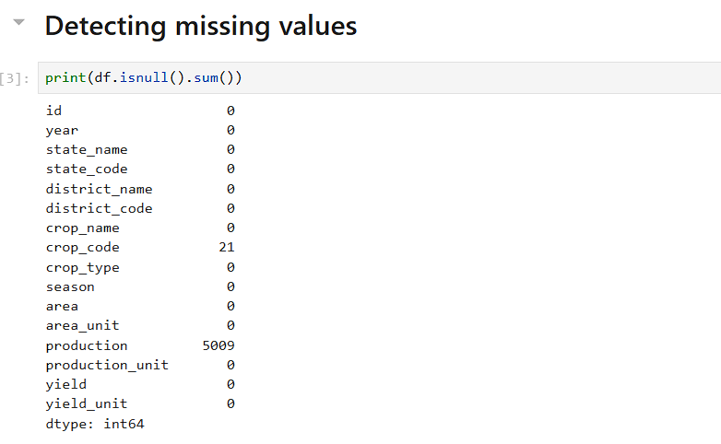
Figure 1: Missing-value counts per column, from the working Jupyter notebook.
4.2 Investigating Missing Values Before Fixing Them
missing_prod = df[df['production'].isnull()]
print(missing_prod[['year','state_name','crop_name','area','production','yield']].head(10))
Rather than immediately imputing or dropping missing values, the affected rows were examined directly. This revealed that wherever production was missing, the yield column had been recorded as 0.0 rather than also being left null - a data pipeline defect, not a genuine zero-yield observation. This finding shaped the cleaning decision: these rows could not be trusted even for their yield value, reinforcing the case for removal rather than imputation.
4.3 Handling Missing Values
df_clean = df.dropna(subset=['production'])
# Before: 455,359 rows -> After: 450,350 rows (5,009 removed)
Imputation (e.g., estimating production as Area x average yield for that crop) was considered but rejected, since it assumes a 'typical' year and could mask genuine anomalies such as drought-driven crop failure. At approximately 1.1% of the dataset, removal was judged unlikely to introduce meaningful bias into state- or crop-level aggregates.
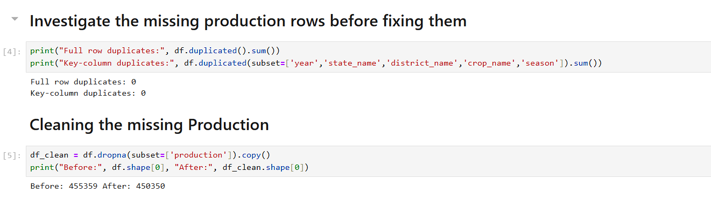
Figure 2: Duplicate-row check (0 found) and missing-production removal, from the working Jupyter notebook.
4.4 Outlier Detection - Global Method (Rejected)
Q1 = df_clean['yield'].quantile(0.25)
Q3 = df_clean['yield'].quantile(0.75)
IQR = Q3 - Q1
lower, upper = Q1 - 1.5*IQR, Q3 + 1.5*IQR
global_outliers = (df_clean['yield'] < lower) | (df_clean['yield'] > upper)
# Result: 65,857 / 450,350 flagged (14.6%)
A standard Tukey IQR check (flagging values beyond 1.5x the interquartile range) was first applied across the entire dataset. This flagged an implausibly high 14.6% of records. Inspection of the flagged rows showed the cause: crops such as Coconut naturally report yield values (tens of thousands of units per hectare) that are orders of magnitude higher than cereal crops (typically 1-3 tonnes/hectare). A single global threshold conflates natural cross-crop variation with genuine anomalies.
4.5 Outlier Detection - Per-Crop Method (Applied)
def flag_outliers(group):
Q1 = group['yield'].quantile(0.25)
Q3 = group['yield'].quantile(0.75)
IQR = Q3 - Q1
lower, upper = Q1 - 1.5*IQR, Q3 + 1.5*IQR
return (group['yield'] < lower) | (group['yield'] > upper)
df_clean['is_outlier'] = df_clean.groupby('crop_name', group_keys=False).apply(
flag_outliers, include_groups=False)
# Result: 14,453 / 450,350 flagged (3.21%)
Recomputing IQR bounds separately within each crop group (a form of normalization, since it adjusts the threshold to each crop's own distribution) reduced the flagged proportion to 3.21% - a statistically defensible figure. Flagged rows were retained rather than deleted: agricultural yield legitimately includes extreme events (severe drought, exceptional harvests), and removing them would discard real signal rather than noise.
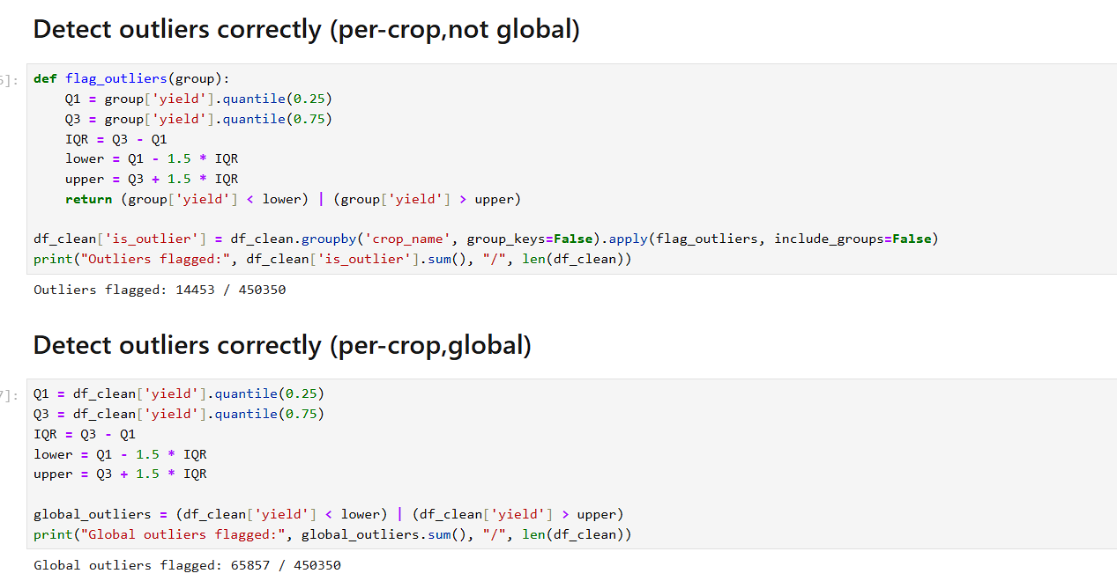
Figure 3: Side-by-side comparison from the notebook - per-crop outlier detection (14,453 / 450,350 = 3.21%) versus the rejected global method (65,857 / 450,350 = 14.6%).
Worked Example: Why Global Bounds Fail for Wheat
wheat = df_clean[df_clean['crop_name']=='Wheat']['yield']
Q1, Q3 = wheat.quantile(0.25), wheat.quantile(0.75)
print(Q1, Q3, Q1-1.5*(Q3-Q1), Q3+1.5*(Q3-Q1))
# Wheat: Q1=1.374, Q3=3.035, lower=-1.118, upper=5.527 (per-crop bounds)
To make the abstract 'crop-scale mismatch' concrete: Wheat's own yield distribution gives an upper bound of about 5.53 tonnes/hectare - reasonable for wheat, and only 16 of Wheat's 12,876 records fall outside it. Under the rejected global bounds (calculated across all crops combined, upper bound about 5.60), 10 of those same Wheat rows would still be flagged - not because those specific harvests were unusual for wheat, but because the global threshold happens to sit close to Wheat's own range by coincidence. For Coconut, the effect is far starker: its own per-crop upper bound is roughly 21,750 tonnes/hectare (Coconut yield is reported on a completely different numeric scale), so every single Coconut record would be flagged as an 'outlier' under the global bounds, despite being entirely normal for that crop. This side-by-side comparison is the concrete evidence behind the decision to use per-crop grouping rather than a single global threshold.
4.6 Handling Zero-Value Production and Yield
df_clean['crop_failure'] = (df_clean['production'] <= 0) & (df_clean['area'] > 0)
# Result: 3,997 rows flagged
3,997 rows recorded area > 0 with production and yield at exactly 0 - distinct from the missing-value case, since these were explicitly reported values rather than absent ones. This pattern plausibly represents genuine total crop failure (e.g., due to drought, pest outbreak, or flood) rather than a data-entry error. Rather than removing or imputing these rows, a boolean crop_failure flag was added, allowing future analysis to include them (when measuring true regional risk/reliability) or exclude them (when measuring typical successful-harvest yield) depending on the analytical question being asked.
4.7 How Flagged Rows Will Be Used in Further Analysis
# Typical-performance KPIs (exclude flags, e.g. Week 1's yield-per-acre benchmarking)
benchmark_df = df_clean[~df_clean['is_outlier'] & ~df_clean['crop_failure']]
avg_yield = benchmark_df.groupby('crop_name')['yield'].mean()
# Risk/reliability KPIs (include flags - they are the subject of the analysis)
failure_rate_by_district = df_clean.groupby('district_name')['crop_failure'].mean()
outlier_events_by_year = df_clean.groupby('year')['is_outlier'].sum()
The is_outlier and crop_failure flags are not treated identically in every downstream analysis - which rows are included depends on the specific question being asked:
- Typical/expected-performance KPIs (e.g., average yield-per-acre by crop, fertilizer efficiency, from the Week 1 KPI plan): both flagged groups are excluded, since including extreme or failed harvests would distort what 'typical' performance looks like.
- Risk, volatility, or reliability KPIs (e.g., a district's crop-failure rate, or frequency of extreme yield events): flagged rows are the primary subject of the analysis and are explicitly included, not excluded.
- Trend analysis over time (e.g., yield variance year-over-year): outlier and failure rates are tracked as their own time series, since a rising failure rate across years is itself a meaningful finding rather than noise to be filtered out.
This means the cleaning stage deliberately stops short of deciding, once and for all, whether an extreme value 'counts' - it instead produces a dataset where that decision is made explicitly and consistently per analysis in subsequent weeks, rather than being silently baked into the cleaning step.
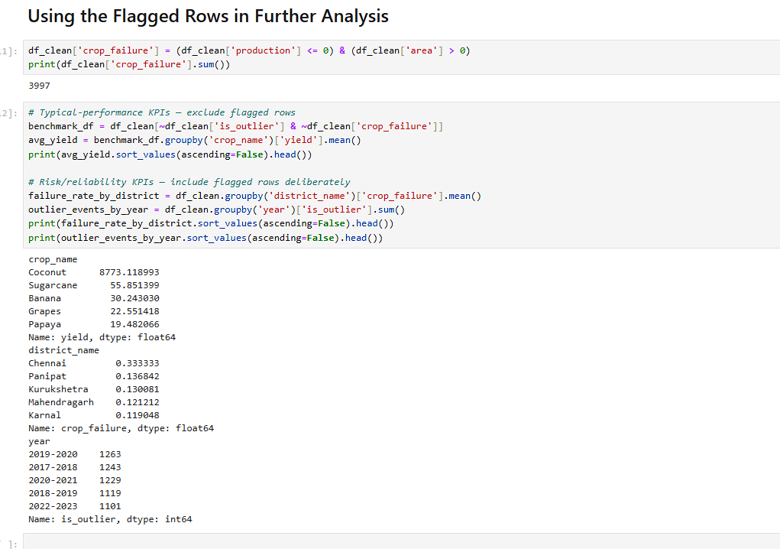
Figure 4: Notebook output showing the crop_failure flag creation, and both the excluded (benchmark) and included (risk/reliability) uses of the flags described above.

5. Theoretical Underpinnings
The cleaning techniques applied are grounded in established statistical reasoning rather than applied as default rules:
- Interquartile Range (IQR) outlier detection: the 1.5x IQR threshold (Tukey's method) defines the 'inner fence' beyond which a value is conventionally considered unusual relative to the middle 50% of a distribution. This method is distribution-agnostic and robust to skew, which suits agricultural yield data that is rarely normally distributed.
- Group-wise normalization: computing separate IQR bounds per crop_name is a form of normalization - adjusting a statistical measure to the local scale/context of a subgroup rather than a global population. This is necessary whenever a dataset combines fundamentally heterogeneous units (here, crops with naturally different yield magnitudes) under one column.
- Missing-data mechanisms: the decision to drop rather than impute rests on the distinction between data missing due to a systemic reporting gap versus data that could be reliably reconstructed. Since the cause of the missing production values could not be established with confidence, imputation risked introducing unjustified assumptions into the dataset.

6. Ethical Considerations in Data Usage
Several ethical dimensions were considered in working with this dataset:
- Licensing and provenance: the dataset is released under the Open Data Commons Attribution License by a government body, and is appropriately attributed in this report; this avoids the consent concerns that can arise with less transparent data provenance.
- Privacy: the dataset is aggregated to the district level and contains no individually identifiable farmer records, avoiding direct privacy risk. However, the individual-level field surveys underlying this aggregation do involve data collected from farmers, whose awareness of and consent to downstream secondary analysis cannot be verified from the aggregated data alone.
- Risk of aggregation bias: district-level averages can obscure within-district inequality - a district average may mask that a small number of large farms perform well while many smallholders struggle. Any conclusions drawn from this data should be qualified with this limitation rather than presented as representative of all farmers equally.
- Risk of mislabeling crop failure: labeling rows as crop_failure based on production = 0 is an inference, not a certainty. Misclassifying a data-entry error as a genuine failure (or vice versa) could distort downstream analysis or policy recommendations if treated as fact rather than a reasoned flag.

7. Challenges Faced and Strategies Used
- Distinguishing missing vs. invalid data: the dataset's missing production values were masked by a false yield = 0, which could easily have been mistaken for genuine zero-yield observations. Strategy: inspecting a sample of affected rows before choosing a cleaning method, rather than applying dropna() or fillna() blindly.
- Choosing an outlier method appropriate to heterogeneous data: an initial global IQR check produced an implausible result (14.6% flagged). Strategy: inspecting the highest-flagged values directly, identifying the crop-scale cause, and switching to a per-crop grouped method - then keeping both results to demonstrate the reasoning in this report.
- Distinguishing real crop failure from data error: zero production with positive area could represent either. Strategy: rather than making an unjustified binary choice, a flag column was introduced so the ambiguity is preserved and left to future task-specific judgment, rather than resolved prematurely during cleaning.

8. Potential Outcomes of the Cleaning Decisions
Each cleaning decision changes what subsequent analysis will show. This section makes those downstream effects explicit, rather than leaving them implicit in the decisions above:
- Dropping missing-production rows (5,009 rows, ~1.1%): the immediate outcome is that any state- or crop-level average computed from this dataset will be based on slightly fewer observations per group. Since the missing rows were not concentrated in one crop or state (they appeared across multiple states, e.g., Haryana and Chhattisgarh, as seen in Section 4.2), this is expected to have a negligible effect on crop-level or state-level averages. Had these rows instead been imputed with an estimated production value, the outcome would differ: any year or district with an unusually high concentration of missing data would have its true variability artificially smoothed over, potentially understating real volatility in future risk analysis (Week 3).
- Flagging (not removing) per-crop outliers (14,453 rows, 3.21%): the outcome is that any yield-per-acre or KPI calculation in Week 1's framework must explicitly decide whether to filter on is_outlier before aggregating - if this filter is forgotten in a future week's analysis, extreme values (both genuine bumper harvests and possible data errors) will pull crop-level averages upward or downward without that being visible in the summary statistics alone. Had these rows been deleted instead of flagged, average yield figures would look more stable, but any subsequent analysis of yield volatility or extreme-event frequency (a planned Week 3 KPI) would be structurally impossible, since the evidence would already be gone.
- Flagging crop failures (3,997 rows) rather than removing or imputing them: the outcome is that district-level average yield figures now include some true zeros. This will pull down average yield for districts with a high crop-failure count (e.g., the districts identified in Figure 4, such as Chennai and Panipat) - which is the intended, informative outcome for a risk/reliability analysis, but would understate 'typical successful-harvest' yield if used without filtering for a benchmarking KPI. Both outcomes are only available because the row was kept and flagged rather than deleted.
In summary: because this cleaning process favored flagging over deletion wherever genuine ambiguity existed, the practical outcome is that the same cleaned dataset can correctly support two different kinds of future analysis (typical-performance benchmarking and risk/reliability analysis) without needing to be re-cleaned - provided each future analysis explicitly states which flags it is including or excluding, as shown in Section 4.7.

9. Recommendations for Continuous Data Quality Improvement
Beyond one-time cleaning, the following changes to the data pipeline itself would prevent these issues from recurring in future years' data:
1. Replace zero-filling with null values for unreported production
- Problem observed: 5,009 rows recorded production = null but yield = 0.0, a false signal indistinguishable from a genuine zero-yield harvest.
- Concrete fix: at the point of aggregation (Directorate of Economics and Statistics data pipeline), change the default fill rule so an unreported production field propagates as null through to the yield calculation, instead of being coerced to 0 before yield is computed.
- Verification: an automated check before each yearly release - count of rows where yield = 0 AND production is null should be exactly 0 once fixed; this can run as a one-line validation script in the existing publication pipeline.
2. Add a mandatory crop-failure status field at the point of district-level reporting
- Problem observed: 3,997 rows had production = 0 with area > 0, with no way to confirm whether this reflects a real total crop loss or a reporting gap.
- Concrete fix: add a required categorical field (e.g., harvest_status with values Normal / Total_Failure / Not_Reported) to the district-level reporting form, so the distinction is captured at the source rather than inferred later by analysts.
- Ownership: this would need to be implemented by the state agriculture departments that feed data upward to the Ministry, since they are the point of original data entry - a realistic first step would be piloting the field in 2-3 states before national rollout.
3. Apply crop-specific range validation before publication
- Problem observed: a single global outlier threshold flagged 14.6% of rows as anomalous purely due to comparing incompatible crop scales (e.g., Coconut vs. cereals).
- Concrete fix: maintain a reference table of expected yield ranges per crop (derivable from this dataset's own historical per-crop percentiles), and flag any newly submitted district-year-crop record falling outside, e.g., the 1st-99th percentile for that specific crop, for manual review before the annual release is finalized.
- Concrete metric: this would allow likely data-entry errors (as opposed to genuine extreme harvests) to be caught and corrected before publication, rather than only discovered downstream by analysts as in this report's 3.21% post-hoc outlier rate.

10. Conclusion
This task applied data cleaning techniques to a real, large-scale agribusiness dataset (455,359 raw records) rather than a purely hypothetical scenario, surfacing genuine data quality issues: missing values with a hidden false-zero defect, no duplicate entries, a crop-scale-dependent outlier problem requiring a normalized per-crop approach, and an ambiguous zero-value pattern best resolved through flagging rather than deletion or imputation. Each decision was grounded in statistical reasoning (Tukey's IQR method, group-wise normalization) and considered against the ethical implications of the data's provenance, aggregation, and potential for mislabeling. The result is a cleaned, flagged dataset of 450,350 rows (post-cleaning), with explicit guidance on when flagged rows are included or excluded in subsequent analysis, ready for the exploratory analysis and modeling planned in subsequent weeks, along with concrete recommendations for improving data quality at the source.

